IMG_256

### **[点微]同城分类信息**

同城分类信息平台

**七牛云设置教程**

**第一步：注册七牛云**

[https://portal.qiniu.com/create](https://portal.qiniu.com/create" \t "http://www.tomwx.cn/_blank)

**第二步：新建 Bucket  设置 URL （特别说明域名填写的时候，前面加http）**

[https://portal.qiniu.com/bucket/create](https://portal.qiniu.com/bucket/create" \t "http://www.tomwx.cn/_blank)

[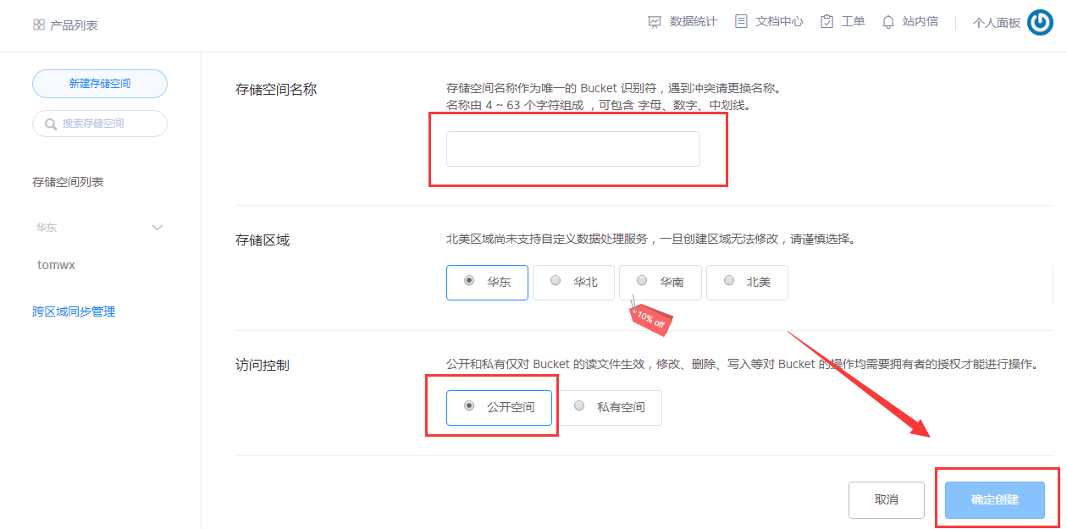](http://www.tomwx.cn/source/plugin/tom_editor/editor/attached/image/20170926/20170926071622_43233.png)

[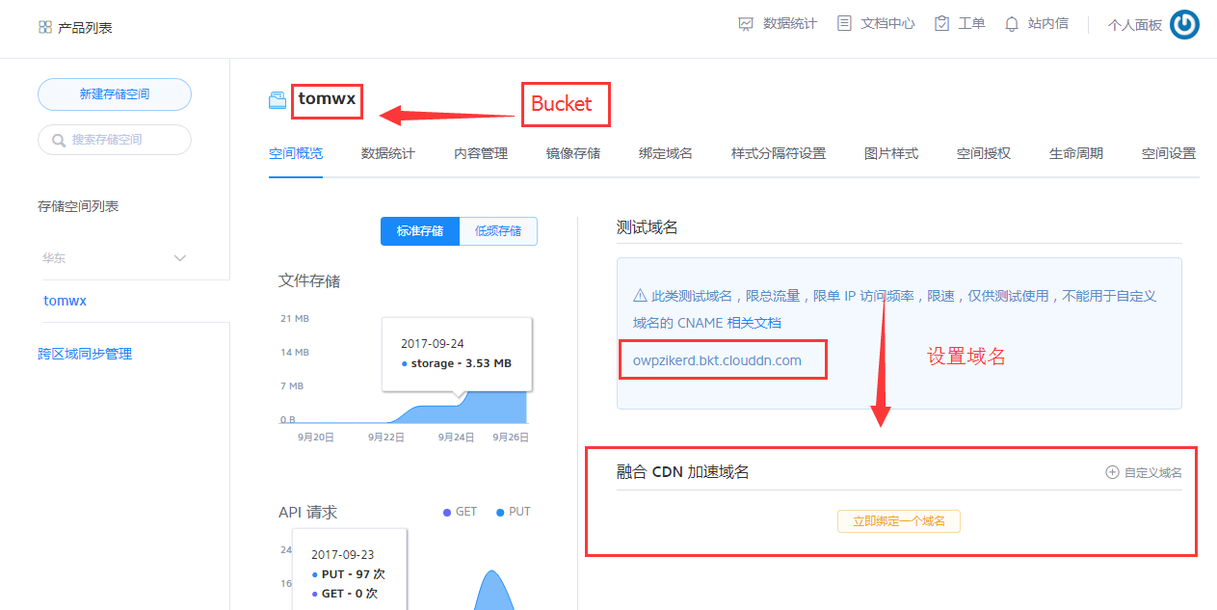](http://www.tomwx.cn/source/plugin/tom_editor/editor/attached/image/20170926/20170926071650_64795.png)

**第三步：获取秘钥**

[https://portal.qiniu.com/user/key](https://portal.qiniu.com/user/key" \t "http://www.tomwx.cn/_blank)

[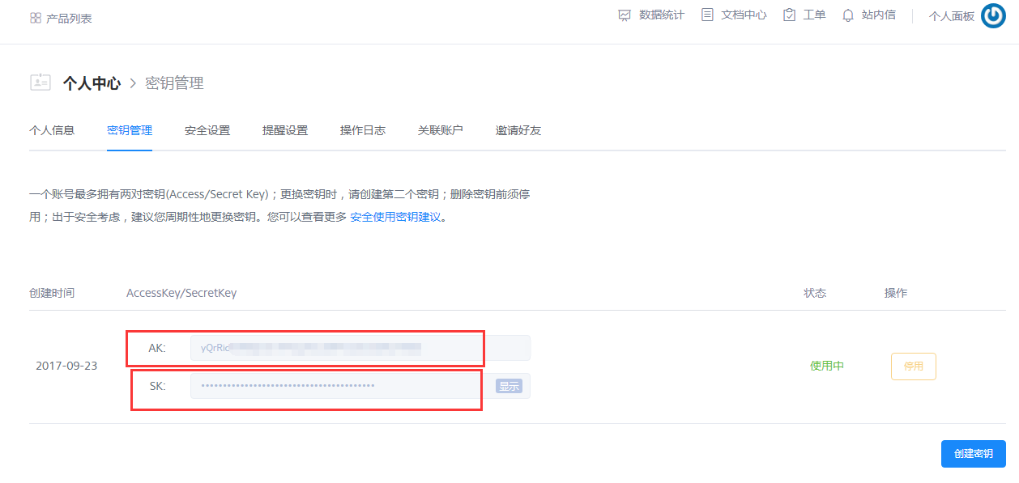](http://www.tomwx.cn/source/plugin/tom_editor/editor/attached/image/20170926/20170926071747_42797.png)

**第五步、后台设置**

[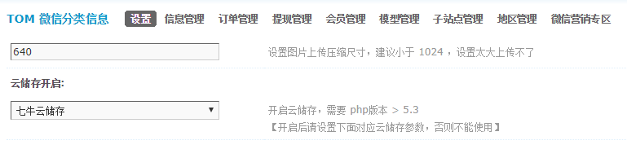](http://www.tomwx.cn/source/plugin/tom_editor/editor/attached/image/20170926/20170926072136_78873.png)

[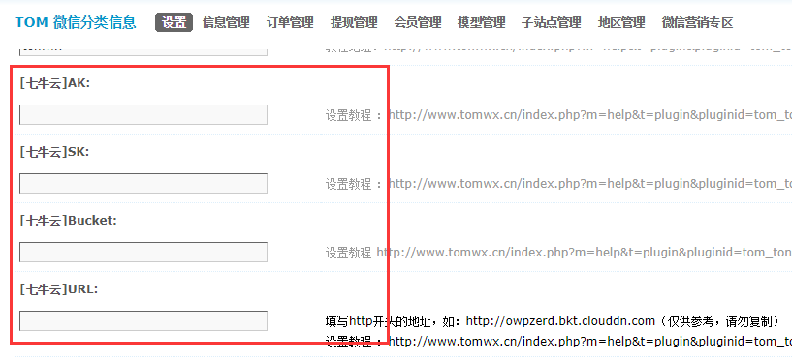](http://www.tomwx.cn/source/plugin/tom_editor/editor/attached/image/20170926/20170926072157_47536.png)

**第六步、手动执行同步之前的图片（点击一次程序会自动后台 执行，但是为了防止程序中断。请一个小时点一次，直到打开出现OVER 表示执行完毕）**

[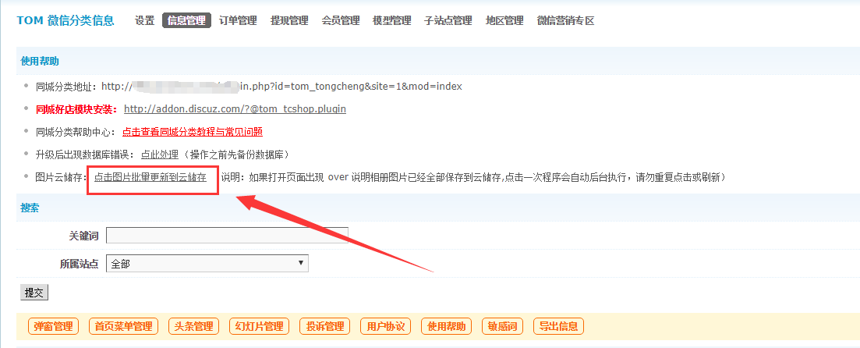](http://www.tomwx.cn/source/plugin/tom_editor/editor/attached/image/20170926/20170926065818_76963.png)